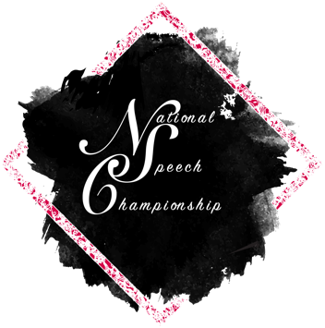
National Speech Championship Internship Description
We are looking for an intern to join the NSC team for a 40-hour paid internship spread out over either a two-week internship this summer or a ten week internship during the 2024-2025 school year. The pay will be $20/hour.
The ideal candidate will have knowledge of collegiate speech and/or debate and has a strong desire to support the growth of NSC and collegiate forensics.
Responsibilities
- Assist the leadership team with accomplishing tasks related to the tournament in 2025 and beyond
- Communicate with other students to determine future tournament preferences
- Support tournament outreach activities by creating promotional content and/or educating others about the tournament throughout the year
- Be an energetic representative of the tournament
- Take part in the 2024-2025 collegiate speech and debate growth initiative
Requirements
- Experience in collegiate speech competition
- Competed in Interviewing at The National Speech Championship
- Loves speech and debate
- Excellent verbal and written communication skills
Benefits Of This Internship
- Practical experience with tournament hosting
- Shadowing, mentoring, and training opportunities with experienced coaches
- Opportunity to customize learning experiences in any or all of, social media content development, event logistics, event production, professional public speaking, experience design, and university administration

